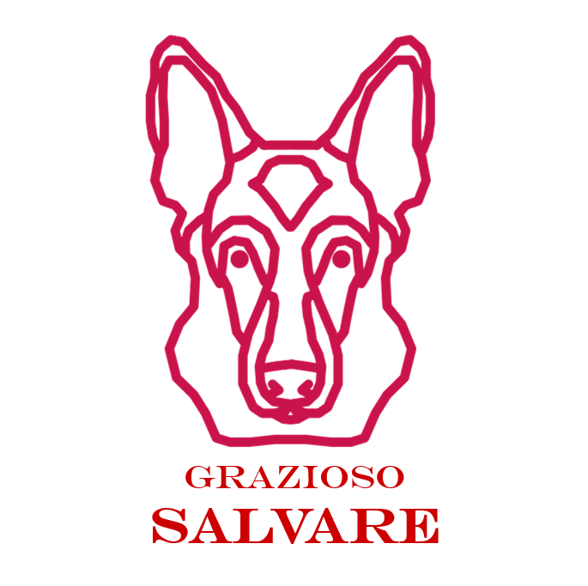

Project Description

The Grazioso Salvare Dashboard is a web application that can sort and filter animals, as well as geolocate any specific animal in the database. It has additional functionality for searching for specific animals, and can even show detailed infographics on them.

Tools Used

- Python is the language chosen and how we developed our CRUD module.

- Dash is what we call our Framework- simply put think of it like the frame of a house- everything else goes around it but it is the core.

- We need a database and so MongoDB was used- this is where we “store” data. For instance we can store information on (a fake example here) a pet named “Spot”. “Spot” can then be further defined- ie as a Labrador Retriever, with a set age, location and more.

- Finally we needed something to make a chart, and that is fixed via plotly..

MongoDB Explanation

MongoDB was chosen as it was simple and easy to use: and integrated well with Python and the other tools chosen.

Dash Framework Explanation

Dash is a framework for building that works with Python. It is incredibly useful and easy to build with. Best of all it is able to integrate other tools- like plotly- and track real time changes. For instance, if a pet was adopted from one location this could be deleted from the database. On the other hand, if one was moved this could be changed too!

Steps Taken

1. First we had to set up both MongoDB and the Python Environment.

2. Create our CRUD operations- this was done in `Module4updated.py`.

3. Now comes the fun part, creating the dashboard. We created filters, sorting, the data table itself, a *py*chart, and more. We named this `Project 2 Final.ipynb`.

4. Implement Callbacks: Call backs, already there, were double checked. This allows for updating.

5. Testing- we had to make sure every single piece worked as designed! It’s not automated like J-Unit testing but every filter, every sort, was tested, the pie chart was ensured to change, etc.

Challenges and Solutions

- Port Errors- Had many issues getting it to connect. Besides MongoDB not working (perhaps an overload late at night?) we had the issues of, the one time it was working, not being able to connect. This was solved when it turned out a previous dashboard (Module 6) was found to be running.

- Sorting- there were issues with the sorting when also applying filters. This was solved by simply giving it time to load- turns out it had a long spooling up time.

Screenshots

Starting State

(Note-reset is hit here as I wanted to show the map. The screen is identical HOWEVER Mongosh is currently down, again. When it is not I will change this. It has been for 5+ hours)

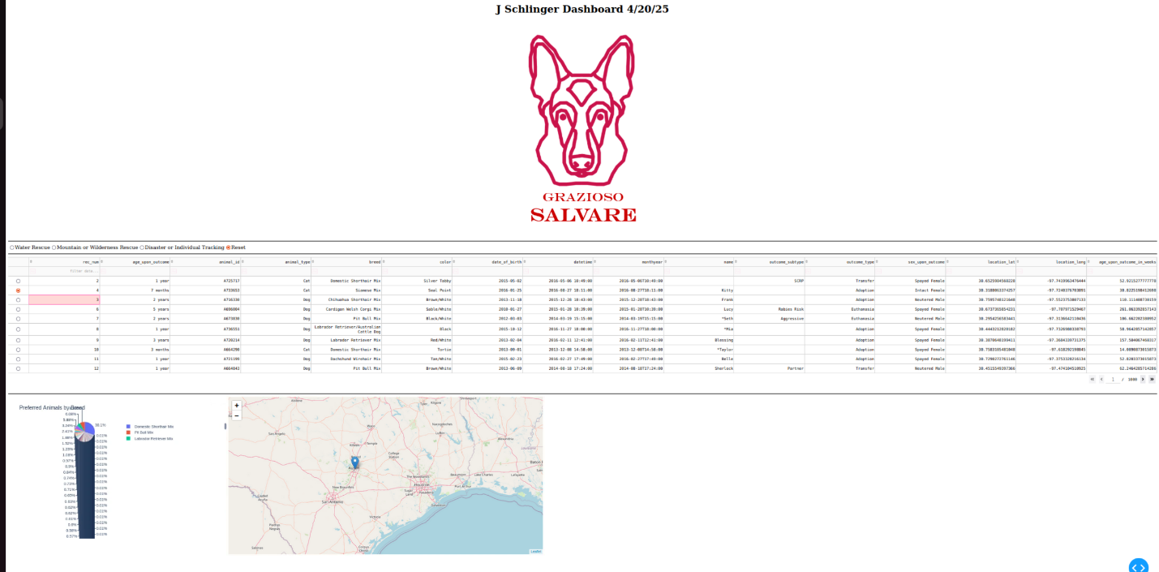

Mountain/Wilderness Rescue Filter

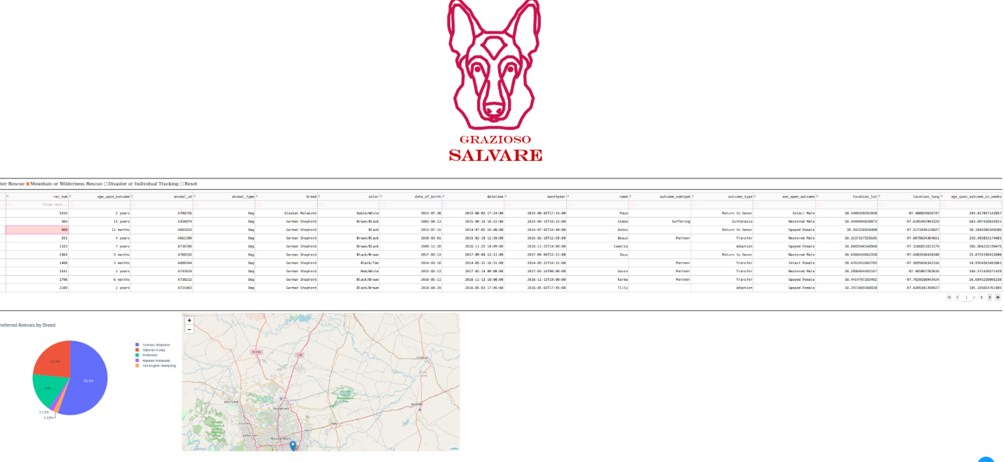

Disaster or Individual Tracking Filter

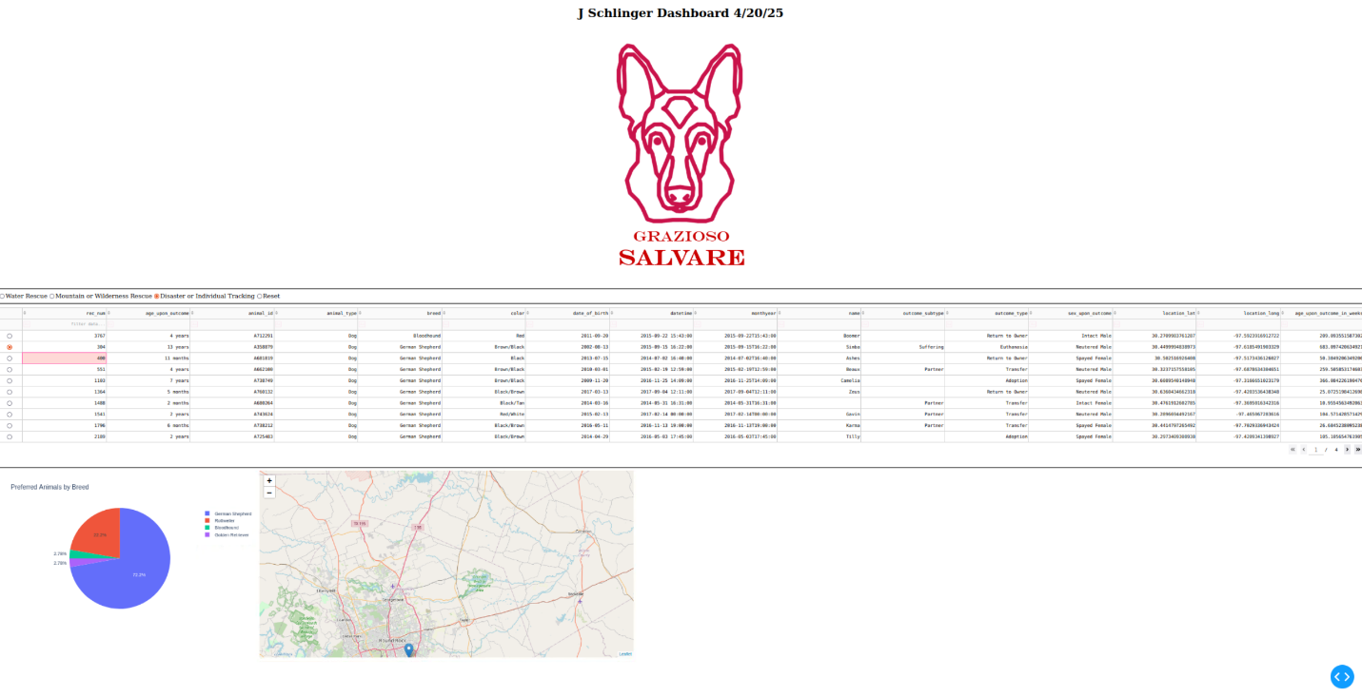

Water Rescue Filter

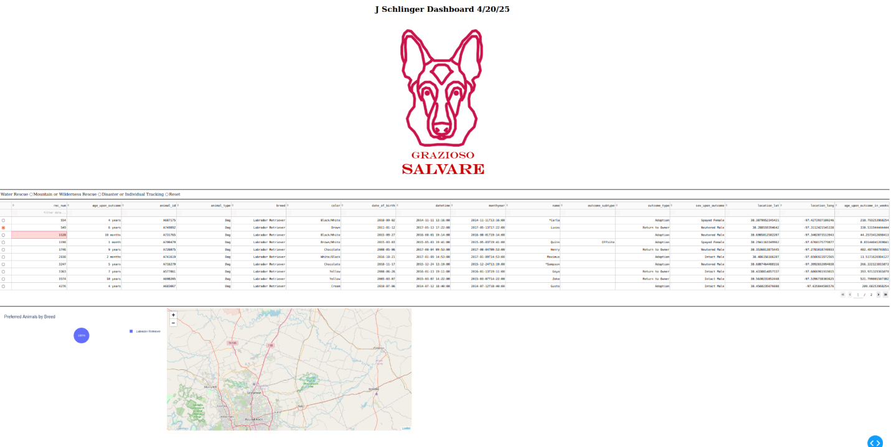

### Reset Filter

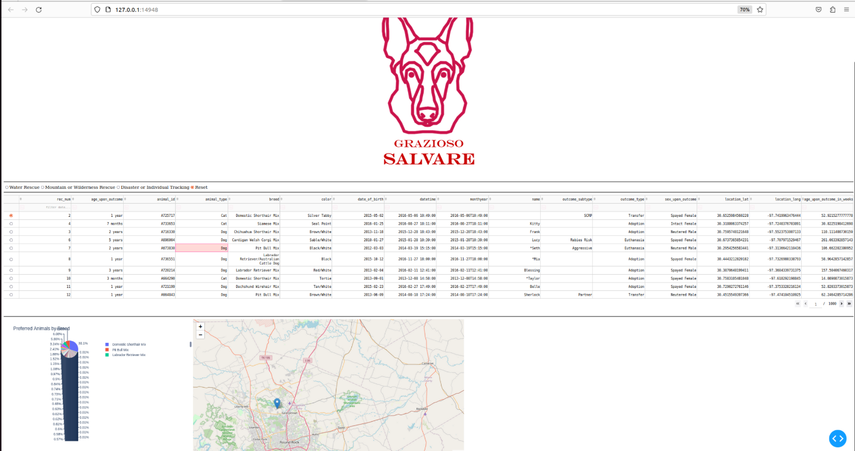

Bonus- Searching with name. Notice it is case sensitive- when searching by dog nothing shows up but when we put in Dog all Dogs show up.

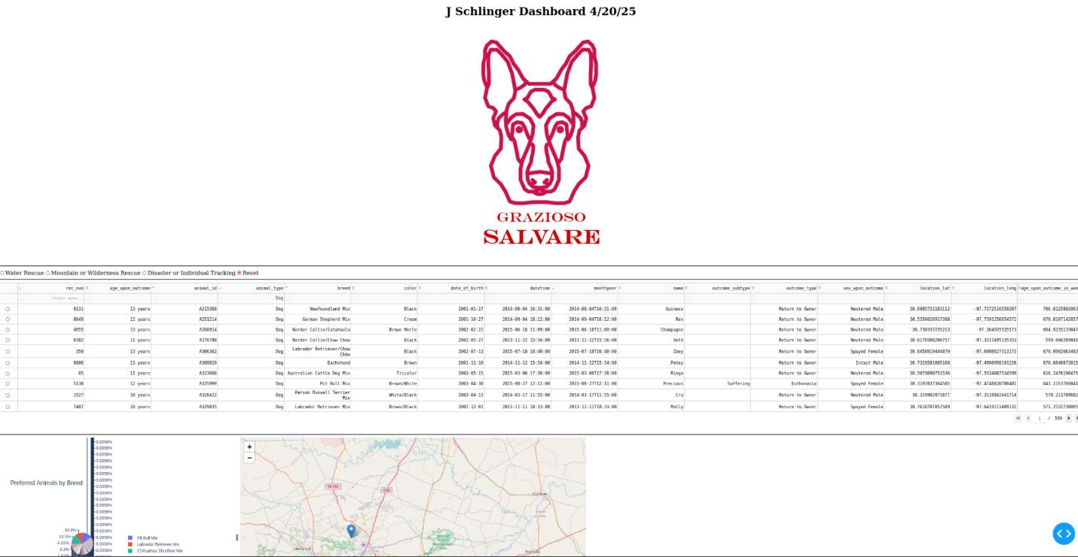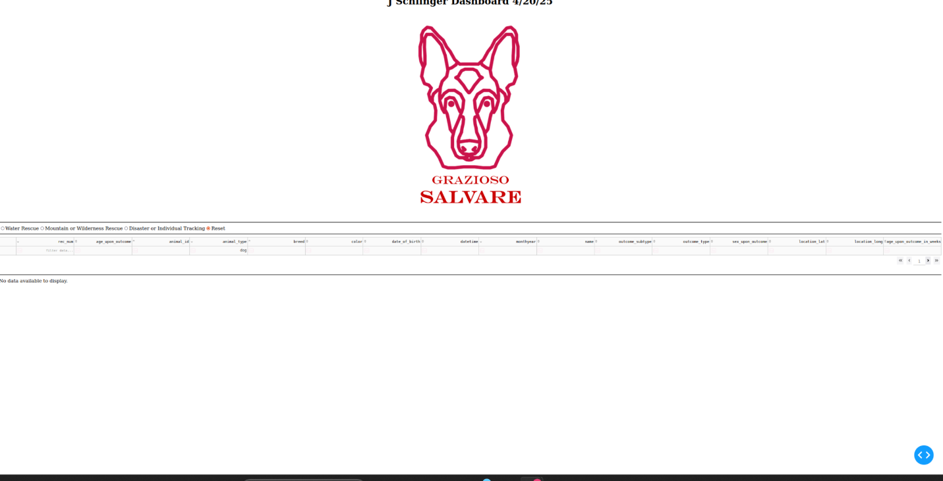

Contact

Jordan Schlinger

817-228-4455

jordan.schlinger@snhu.edu